PowerBI Fundamentals

**Introduction To Business Intelligence**

Data Warehousing Concepts

A data warehouse is a relational database that aggregates structured data from across an entire organization. It pulls together data from multiple sources—much of it is typically online transaction processing (OLTP) data. The data warehouse selects, organizes and aggregates data for efficient comparison and analysis.

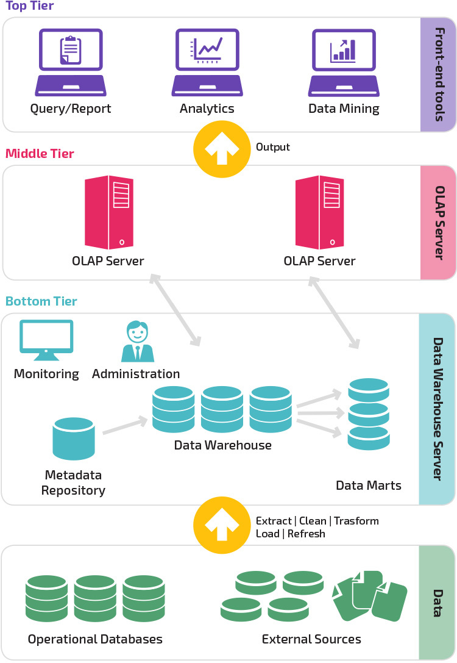

A data warehouse maintains strict accuracy and integrity using a process called Extract, Transform, Load (ETL), which loads data in batches, porting it into the data warehouse’s desired structure.

Data warehouses provide a long-range view of data over time, focusing on data aggregation over transaction volume. The components of a data warehouse include online analytical processing (OLAP) engines to enable multi-dimensional queries against historical data.

Data warehouses applications integrate with BI tools like Tableau, Sisense, Chartio or Looker. They enable analysts using BI tools to explore the data in the data warehouse, design hypotheses, and answer them. Analysts can also leverage BI tools, and the data in the data warehouse, to create dashboards and periodic reports and keep track of key metrics.

With the advent of data lakes and technologies like Hadoop, many organizations are moving from a strict ETL process, in which data is prepared and loaded to a data warehouse, to a looser and more flexible process called Extract, Load, Transform (ELT).

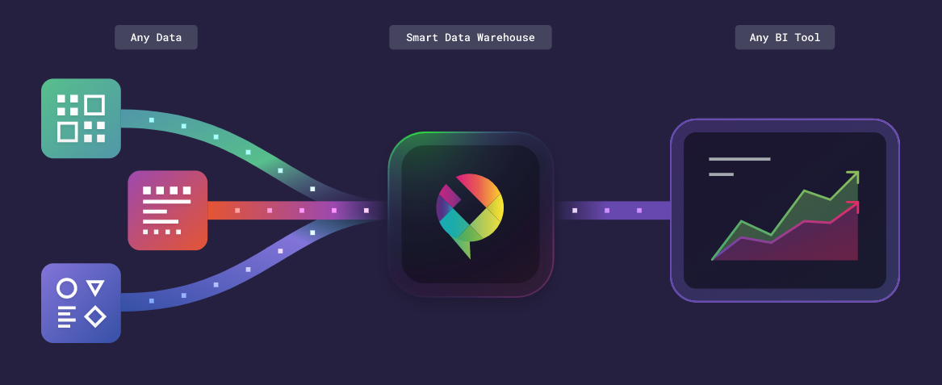

Today ELT is mainly used in data lakes, which store masses of unstructured information, and technologies like Hadoop. Data is dumped to the data lake without much preparation or structure. Then, analysts identify relevant data, extract it from the data lake, transform it to suit their analysis, and explore them using BI tools.

Advantages and Disadvantages of Power BI

What is Power BI?

Power BI is a cloud-based business intelligence service suite by Microsoft. It is used to convert raw data into meaningful information by using intuitive visualizations and tables. One can easily analyze data and make important business decisions based on it. Power BI is a collection of business intelligence and data visualization tools such as software services, apps and data connectors that together constitute Power BI.

We can use the datasets imported in Power BI for data visualization and analysis by making sharable reports, dashboards, and apps. Power BI is a user-friendly tool offering impressive drag-and-drop features and self-service capabilities. A user can deploy Power BI on both on-premise and on-cloud platforms.

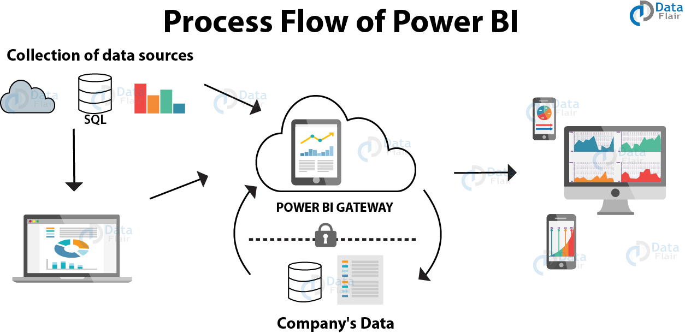

**Pros of Power BI**

* Affordability
* Custom Visualizations
* Excel Integration
* Data Connectivity
* Prompt Updates
* Power BI Embedded
* Personal Gateway
* Data Accessibility
* Interactive Visualizations

**Cons of Power BI**

* Table Relationships
* Configuration of Visuals
* Crowded User Interface
* Rigid Formulas
* Handling Large Data Volumes. Power BI has a limit of ingesting data at a time which is approximately 2 GBs of data. If you wish to import and use data of even greater volumes, you need to extend your free version to a paid version of Power BI
* Complex to Understand and Master. Usually, Power BI is the easiest to use BI tool if you are using it simply to import data and create reports. But Power BI is an entire suite having a lot of other interrelated tools. When the purpose of your use is more than just creating reports in Power BI Desktop, you need to learn and master several other tools like Gateways, Power BI Report Server, Power BI Services, etc.

Downloading and Installing Power BI

1. <https://powerbi.microsoft.com/en-us/downloads/>

Aside from the PowerBI Desktop, there is also PowerBI Cloud and PowerBI Desktop.

1. For signing in, you cannot use your personal email. If you don’t have a school or corporate email, you can continue using as guest (not signed-in)
2. Download the dataset files for our activities

<https://drive.google.com/file/d/1TO-J7BXrISCPM98QBEHNloZ8PRLM10NZ/view?usp=sharing>

Power Bi Environment Exploration

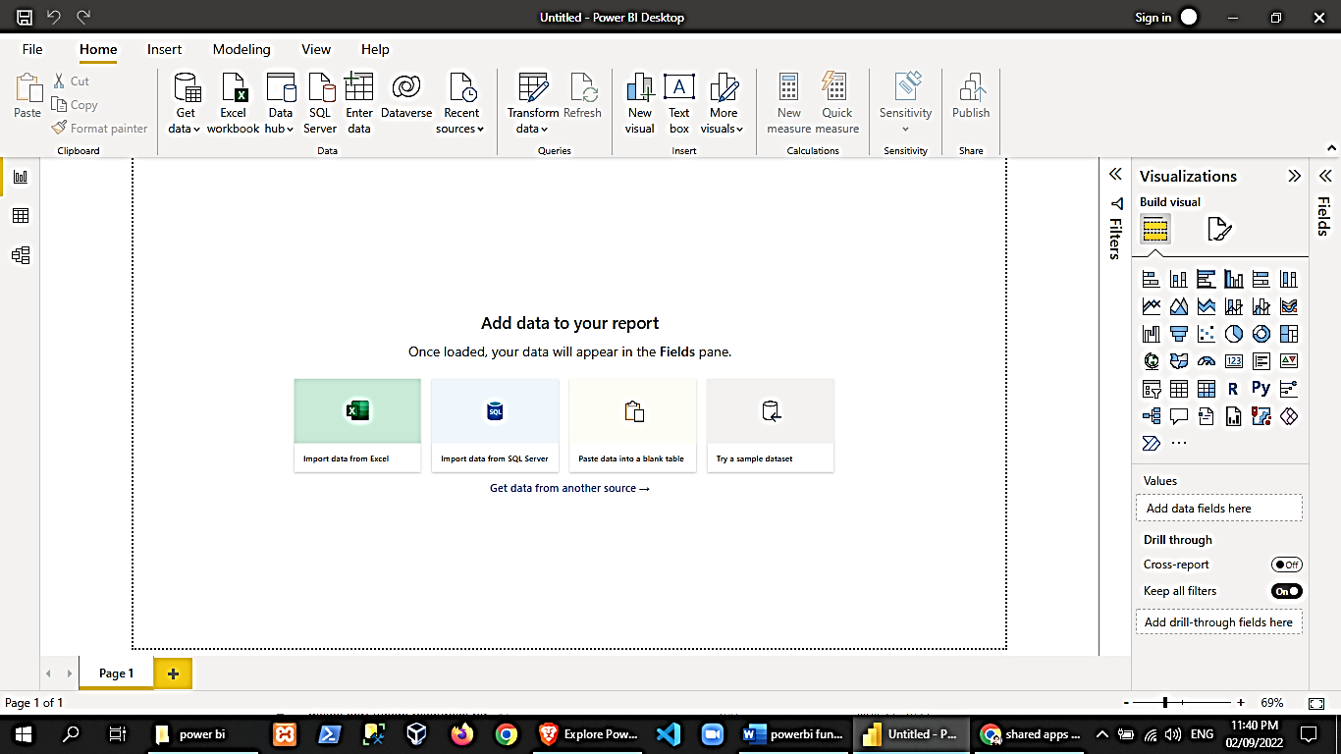

**Report-Data-Model Views**

**Workplace**

**Fields-Visualizations-Filters Panel**

**Office Tabs and Ribbons**

Power BI Use-case scenarios

Organizations deal with lots of data regularly. But in case you are not able to access or connect with that important data, you are not yielding anything. You are keeping your organizations away from getting the value.

Microsoft Power BI will help you solve this problem with the help of a powerful business intelligence tool that mainly stresses on Visualization. Microsoft Power BI is a fundamental programming framework for organizations with huge amounts of disparate data developed during normal business operations. Power BI has numerous uses in building a software system.

* Data Visualization
* Server-Level Data Management
* Analytics With Internal Software Systems
* Provide complex data within software and apps
* Streamline Organizational Processes
* Visualize Details Easily
* Enhance the marketing
* Real-Time look at the company’s financial performance
* Create Consistent Reporting Standards

**Starting a Power BI Project**

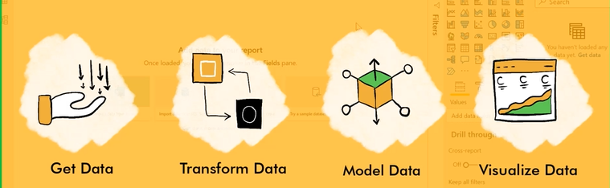

1. Prepare dataset

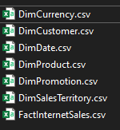

1. PowerBI🡪Home tab🡪get data🡪text/csv🡪import DimCurrency.csv

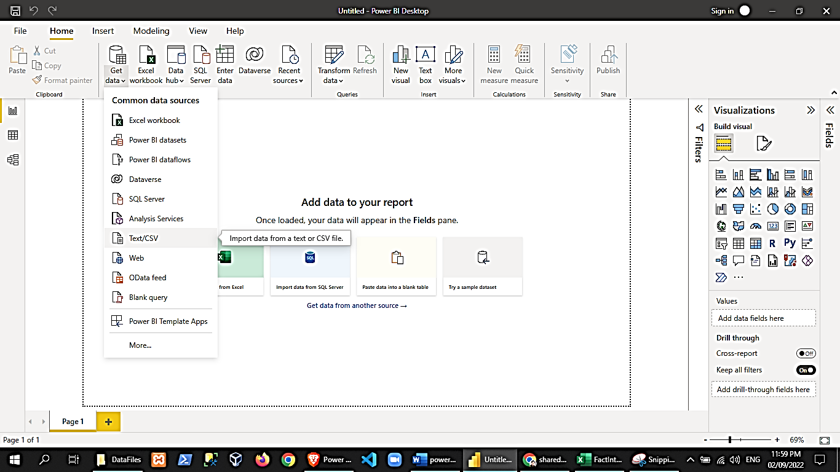 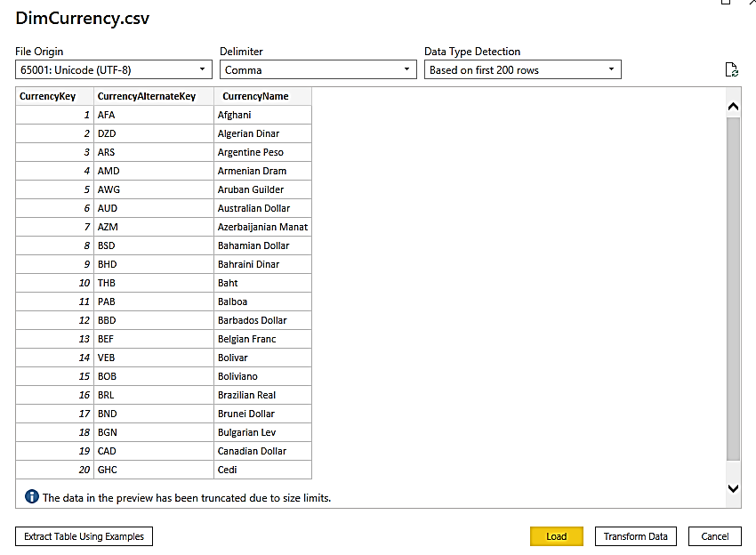

1. Try clicking on transform data to bring up the power query editor

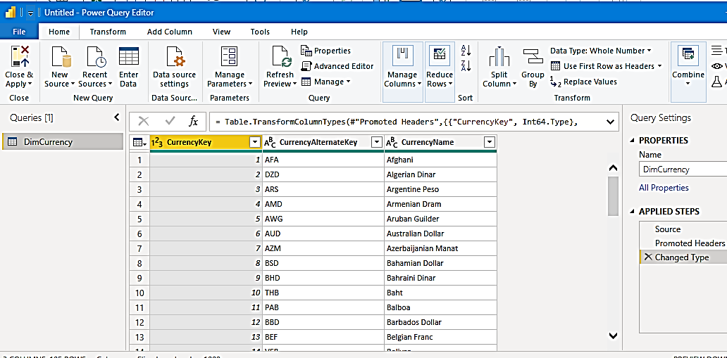

Note: The PowerQuery Window is where we will perform most of our PowerBI data manipulation before we load it on our visualizations.

1. Notice on the right pane, it has a history of applied steps

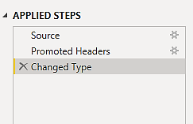

First there was a connection to a source (click on the gear icon of the specific step in the applied steps section)

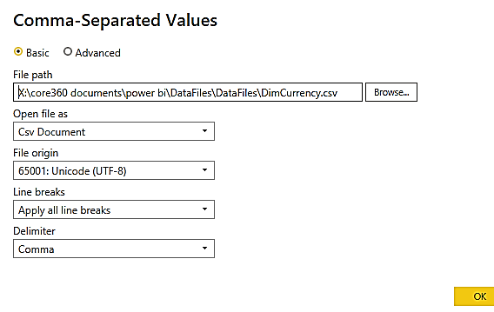

Second, it promoted the first row as the header names

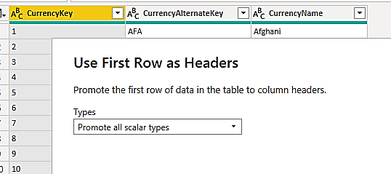

Third, it changed the data types

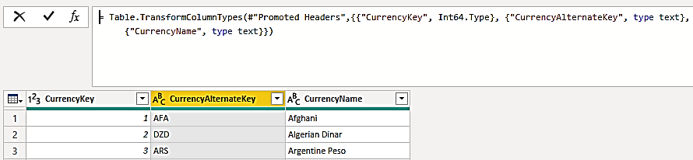

1. Click on home🡪close and apply

You can click on the data view option in the left pane to verify the data has been loaded:

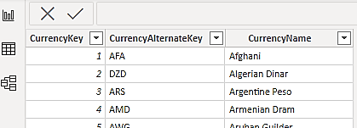

1. Load the other datasets (csv files)

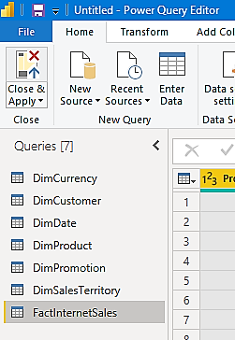

1. In the dimsalesterritory, convert the salesterritory alternatekey column to date. Notice the error, you may delete the row as needed to fix the issue.

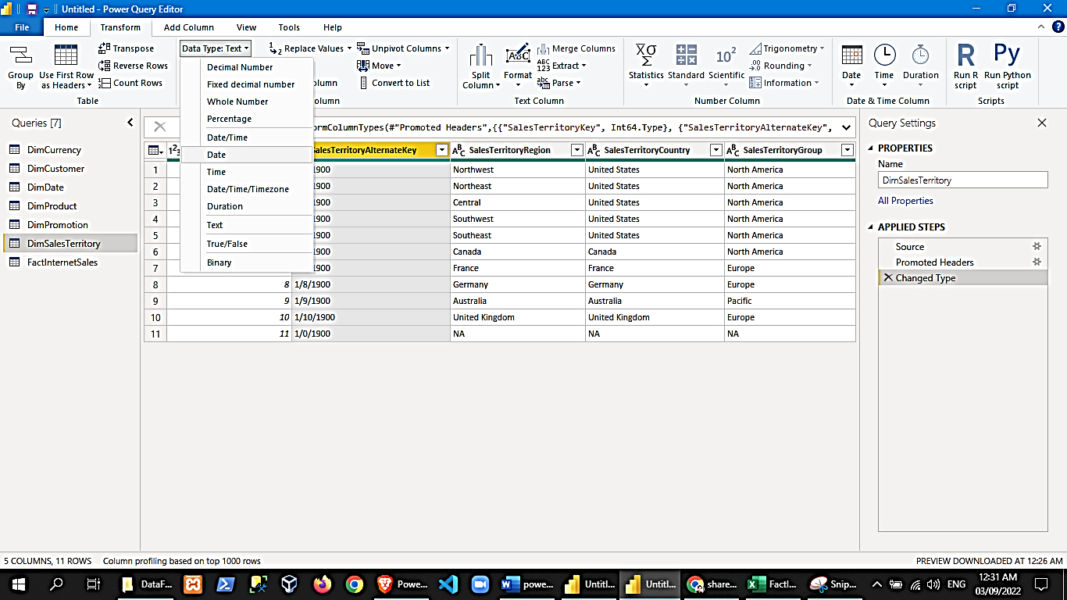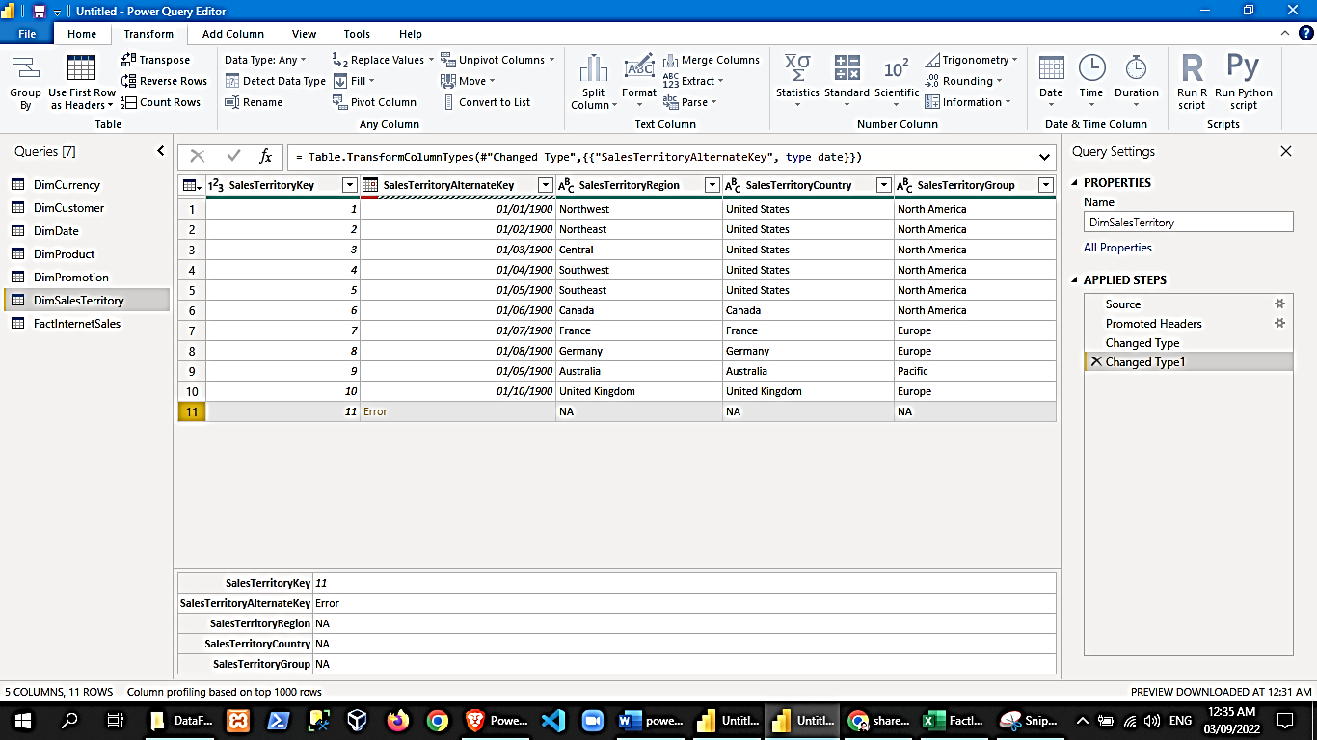

1. In the DimPromotion table:

* Remove empty columns

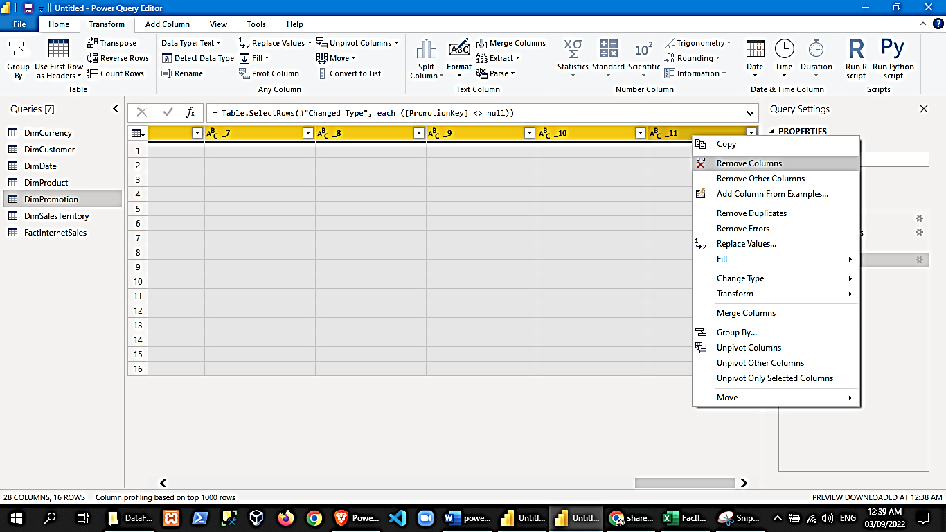

* Remove empty rows

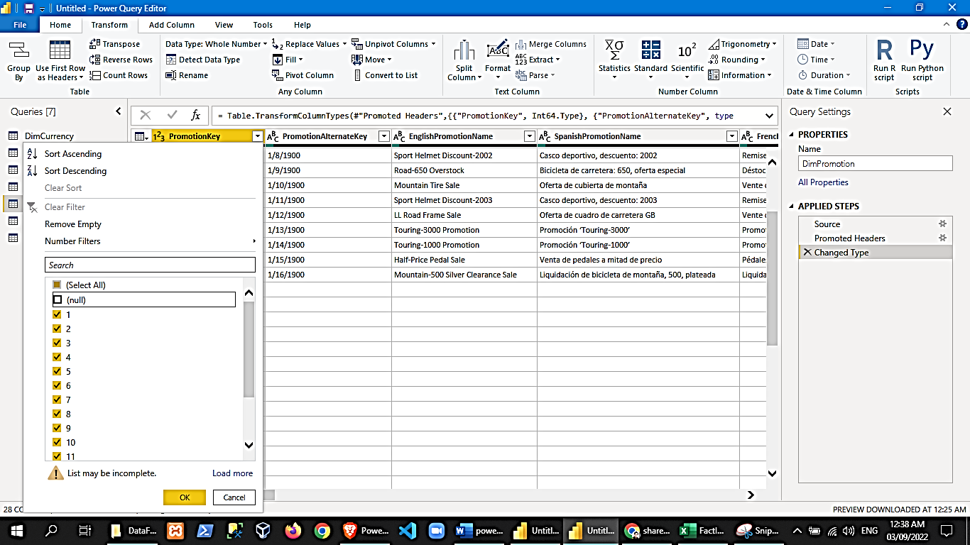

1. In the DimProduct

* Remove empty columns
* Remove empty rows
* Convert dates to date data type
* Check for weird entries in the ProductKey Column

1. In the dimdate table

* Remove empty columns
* Remove empty rows
* Convert dates to date data type (notice the errors)

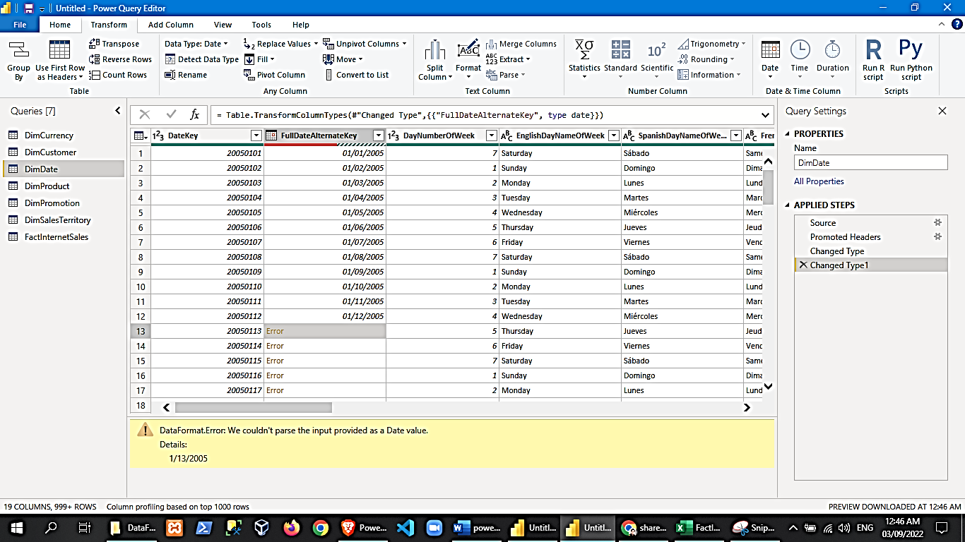

The error above is because of the date/time locale settings where the month and date format are different. To convert dates using locale:

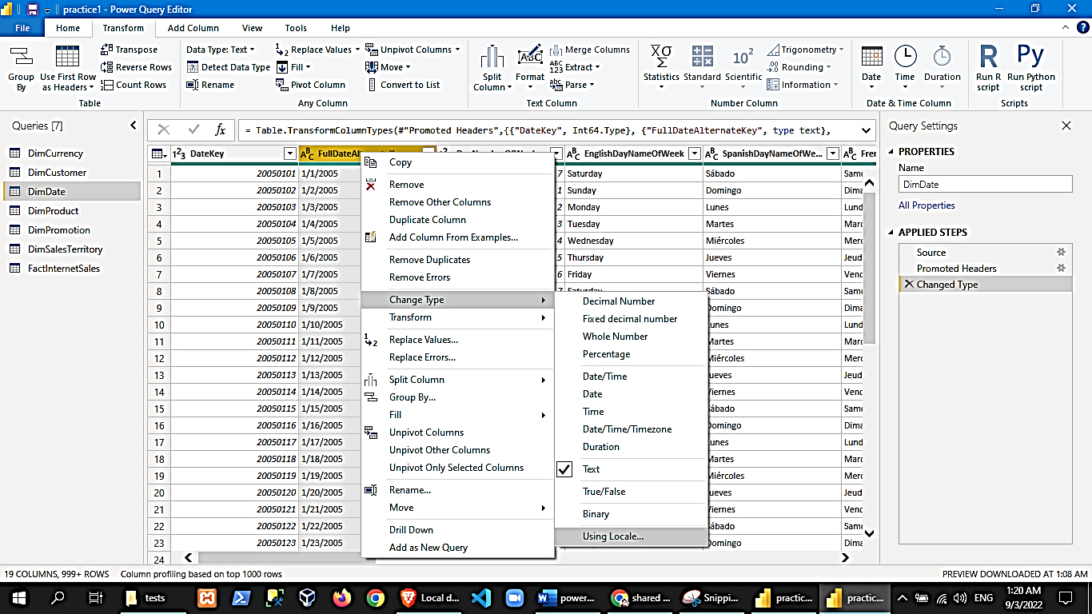 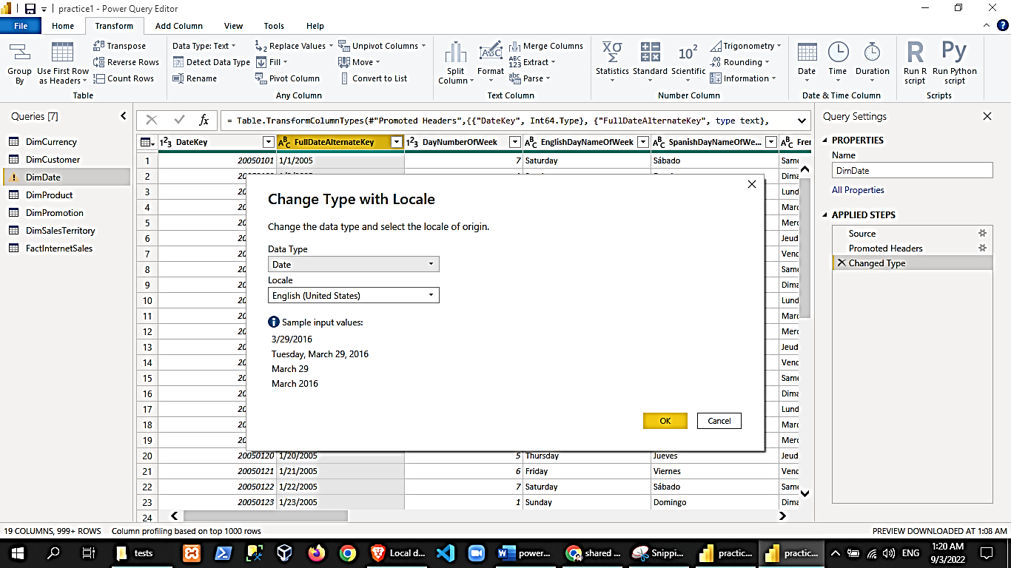

1. In the dimcustomers table

* Remove empty columns
* Remove empty rows
* Convert dates to date data type (you may want to implement the rclick column 🡪convert to🡪using locale)

1. Save (ctrl+S), it will implement the pending changes to reload the dataset into memory.
2. Now let us group our queries tables. In the powerquery window left pane, create 2 group: Facts and Dimensions. Drag the tables into their corresponding groups. You may rename them afterwards.

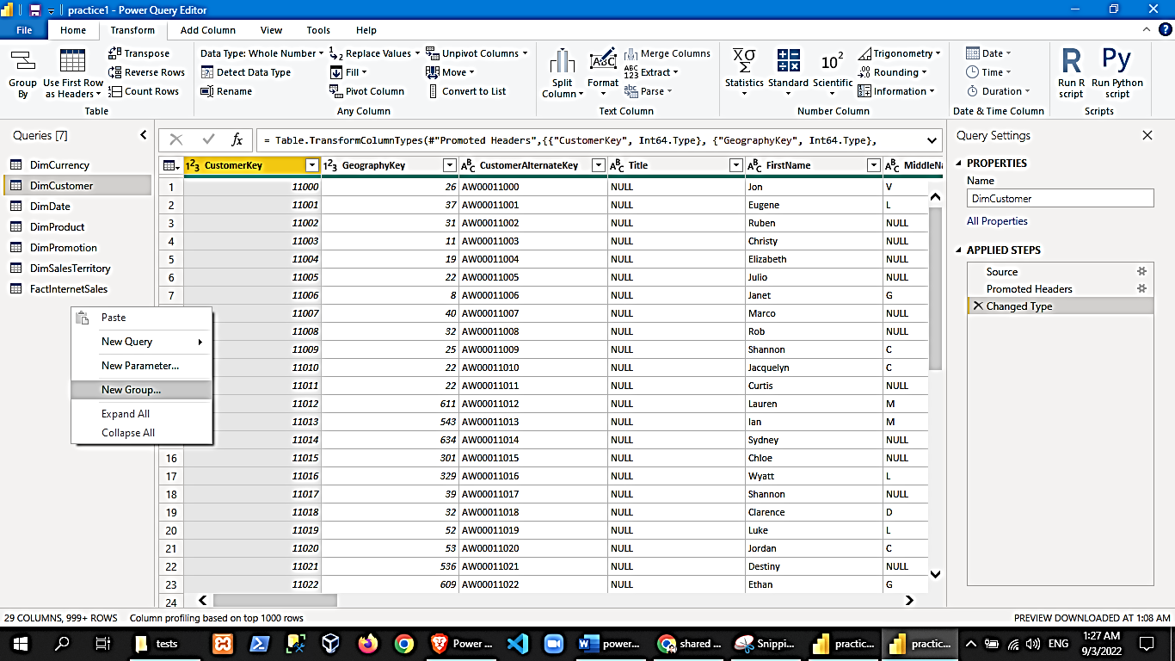 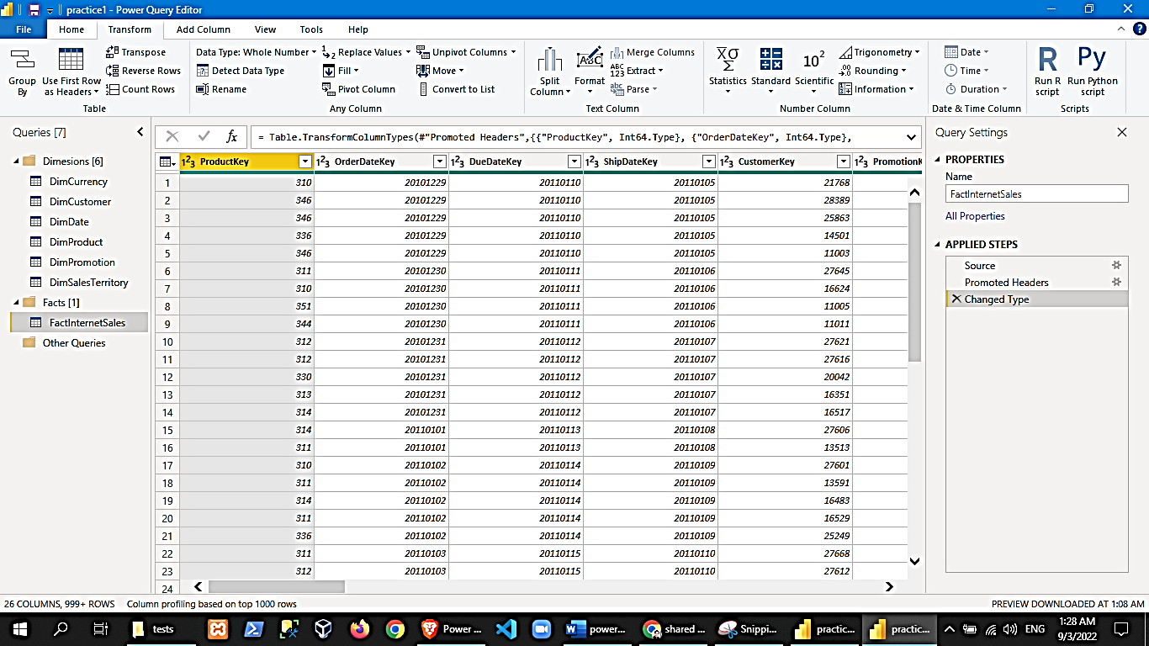

1. Let us try the split column feature. The split column function separates one column into two depending on the delimiter specified.

Product

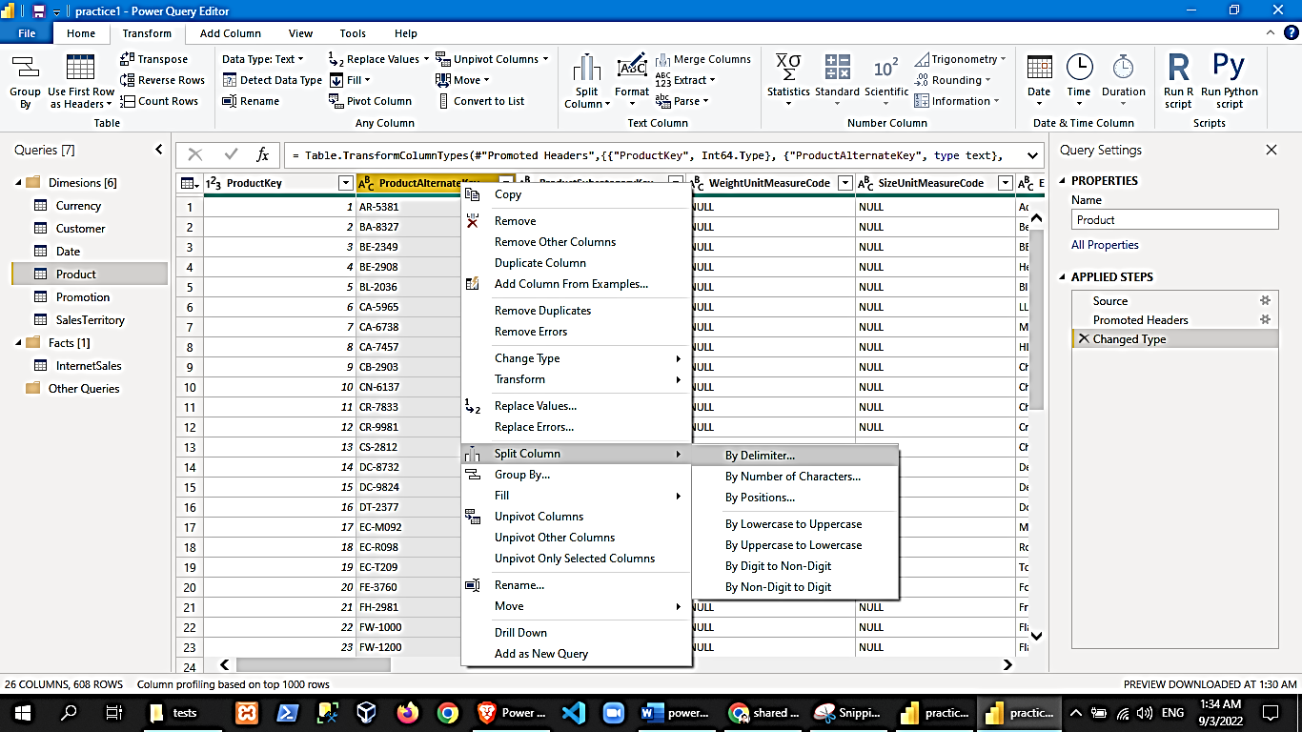 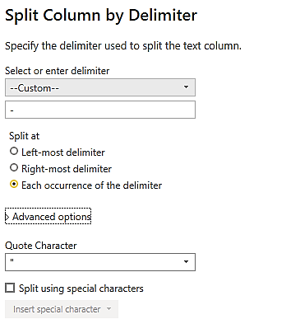

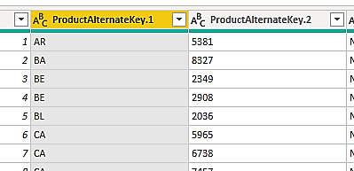

*each actions you perform adds an entry to the applied steps. It is recommended to rename the applied steps so you’ll know exactly what you did in that step.

1. Let us try adding a column to the Customer Table. The Customer table have the ff columns: Firstname, MiddleName, LastName. Now let us add a FullName column in PowerQuery (add column tab🡪custom column):

Customer

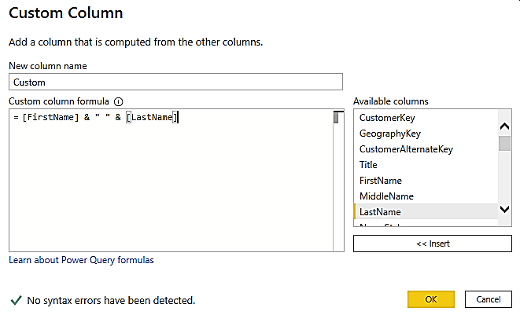

1. Let us try removing error rows in SalesTerritory

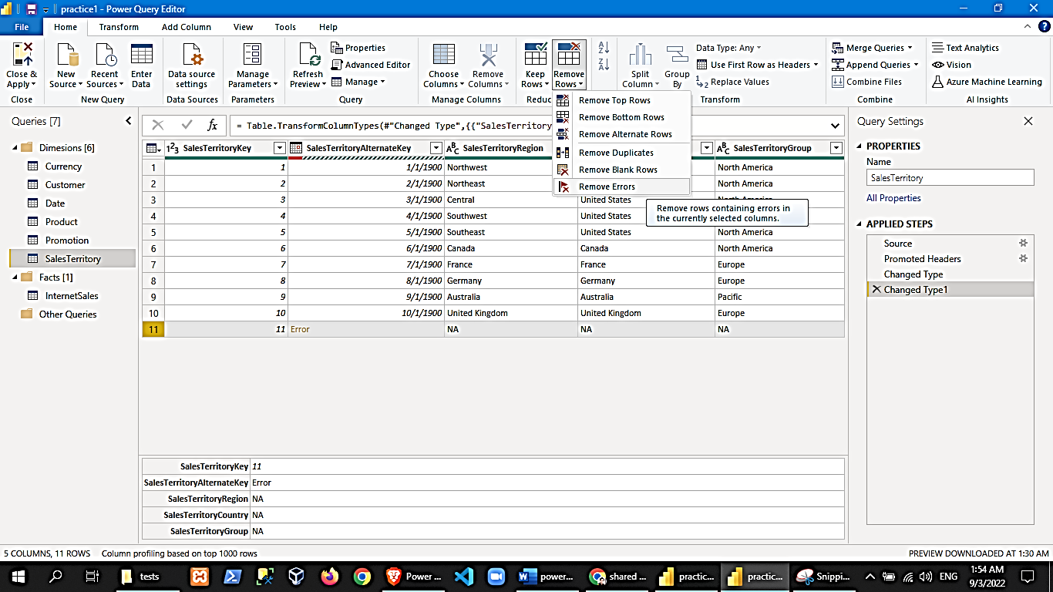

1. Viewing our tables in PowerBI
2. Once you are done in power query, you can click on the “close and apply” button to go back to the powerbi dashboard.
3. In the powerbi dashboard in the left pane, you have 3 views – Report, Data and Model. Click on the data view to see your tables. You can also select which table to view along with each of their corresponding field columns from the field list on the right.

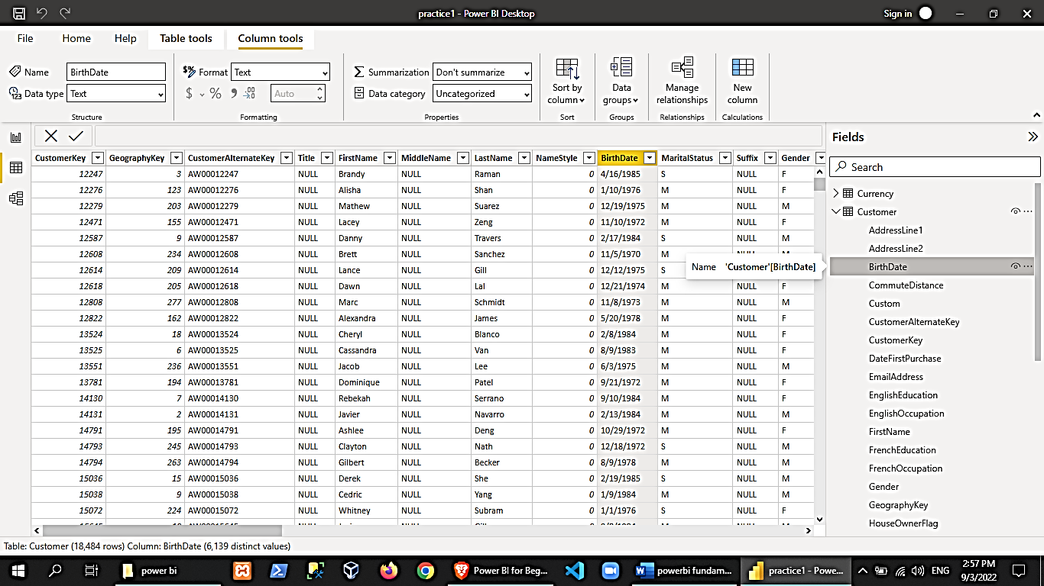

1. You can also check on the powerbi model view from the left pane. Here you can see the tables and their relationship(s) with one another.

Data Modelling is a concept where you try to structure the data along with the right connections are made from the right table to the right entities.

If we see unconnected fields from related tables we can try fixing it here. To create a relationship, you can drag the fields from table to table.

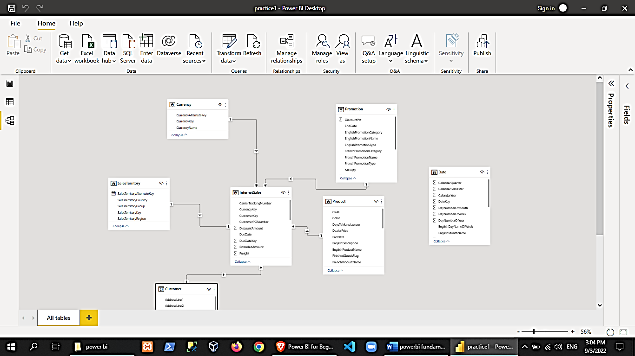

You can doubleclick on a relationship arrow to see and edit relationships.

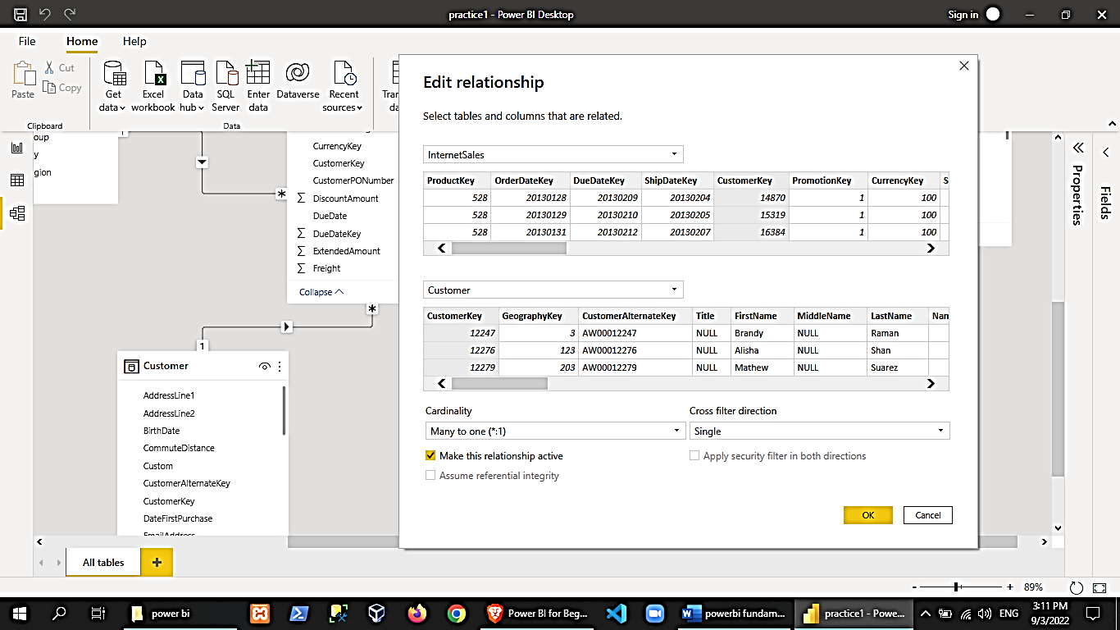

1. Now back in the powerbi dashboard, click on the report view in the left pane. Then select a chart in the visualization pane on the right. For this example, let us select clustered column chart.

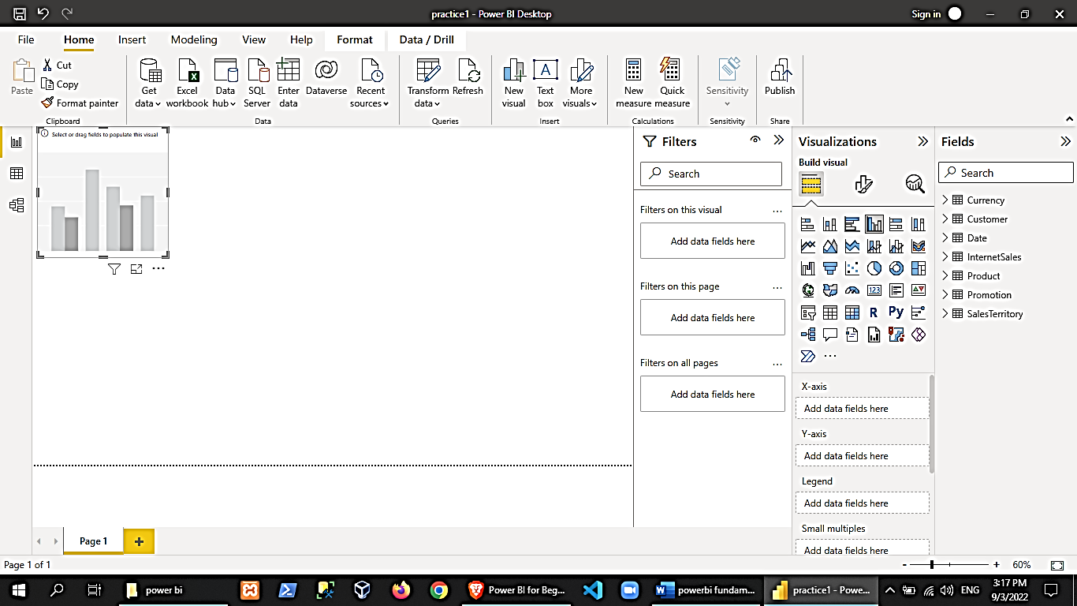

1. Then, we will add data to this visualization.

From the fields list on the right:

* Expand the Sales Territory 🡪 check the SalesTerritoryRegion.
* Expand the Internet Sales 🡪 check the SalesAmount

After doing these, the matrix with be visualized as follows

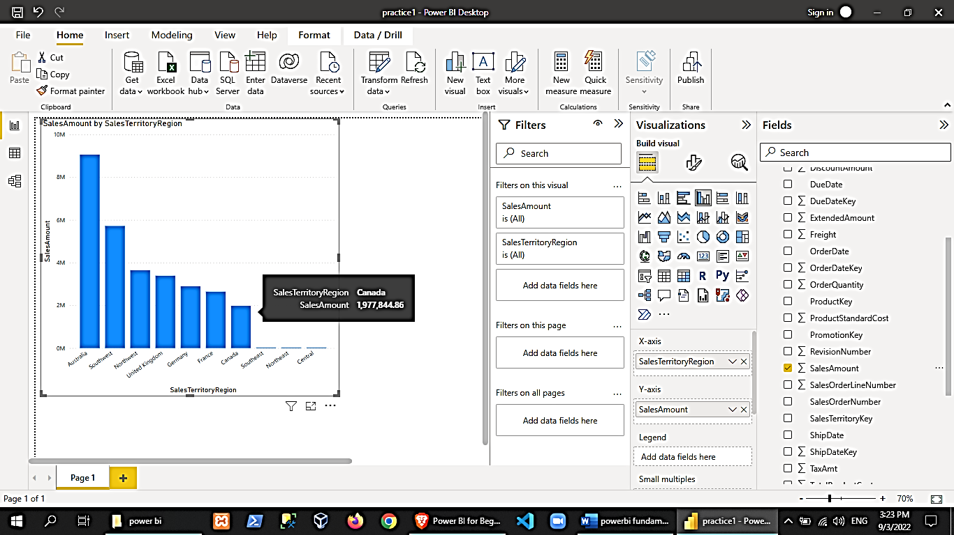

1. Let us another column to make our chart more descriptive

In the fields pane 🡪 rclick the Sales Territory table🡪new column, and use the following formula:

Full Territory Name = [SalesTerritoryCountry] & "-" & [SalesTerritoryRegion]

Click on the validation and press enter. The new column should now be present under the Sales Territory table.

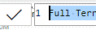

Now, uncheck the SalesTerritoryRegion field and check the Full Territory Name

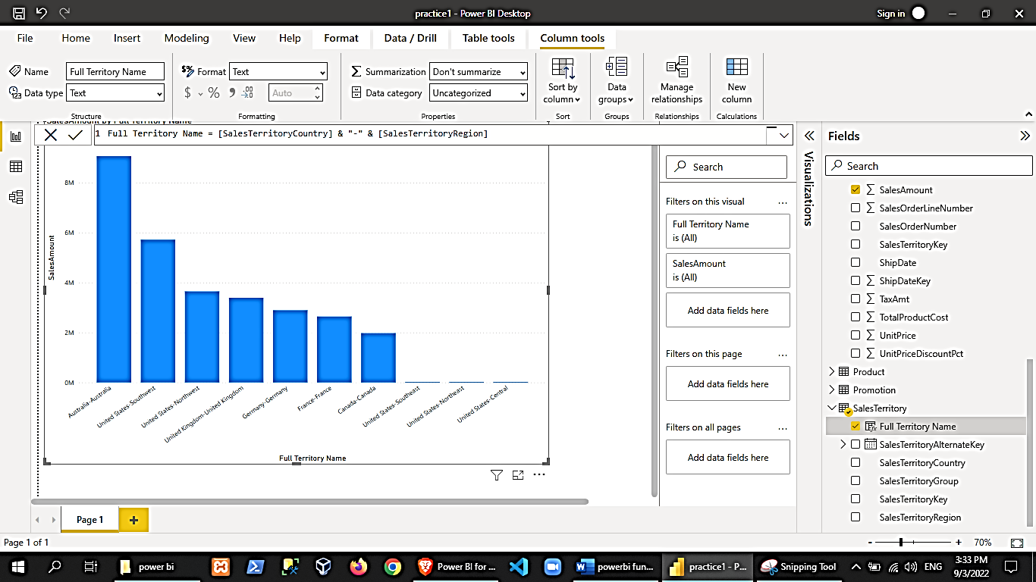

By hovering over the visualization, you can see more options

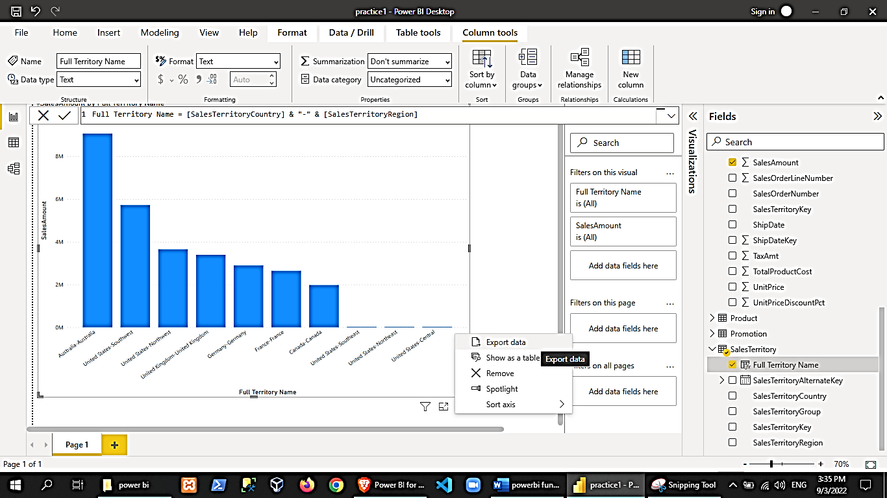

1. Data Exploration
2. Before we generate reports, we can create scratch and small visuals to explore and profile our data.
3. Picking up from the previous activity, let us try changing our clustered column chart to stacked column chart. Then add from the products table the English product name

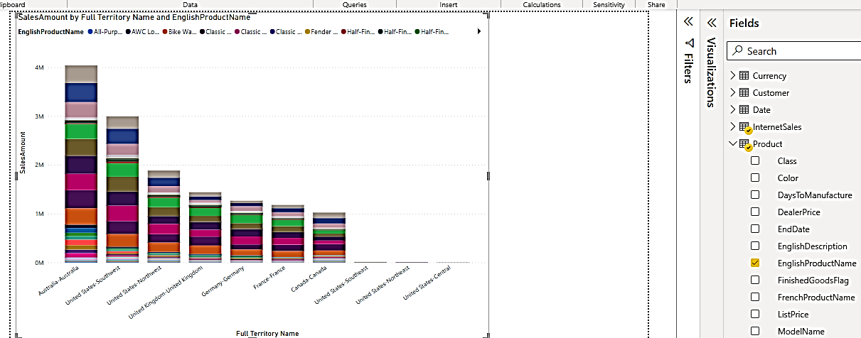

1. We can see the products but we are looking at a lot of data here, so let us try filtering our output. Let us try checking the top 5 products. For the value, you can drag the SalesAmount column from the fields pane.

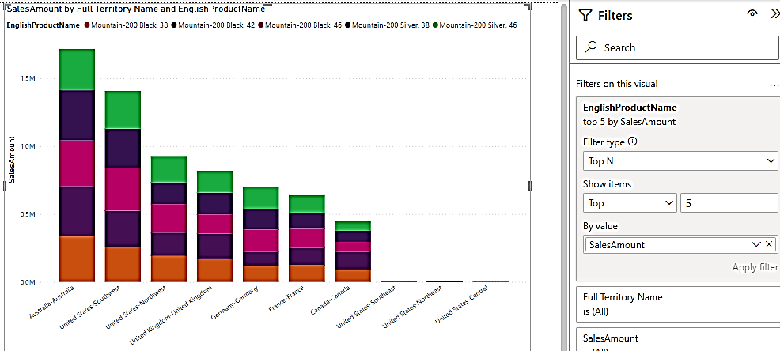

*we can try applying other filter options

1. You can hover over the visualization to see the data as tooltips. You can also rclick on a column🡪show on table.

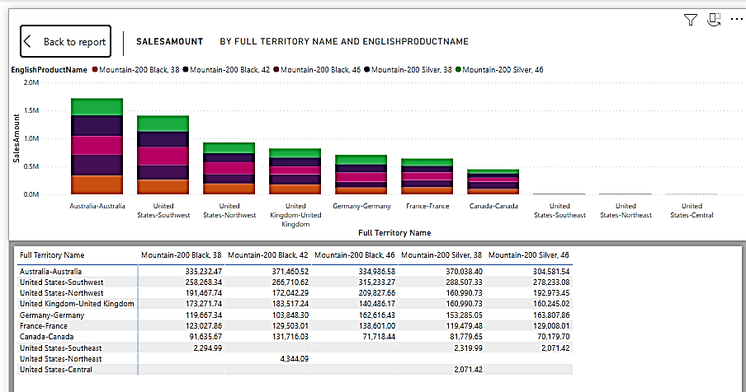

1. Click on “back to report” button. Then make a copy of the chart (copy-paste). Remove the English product name field from the 2nd chart.

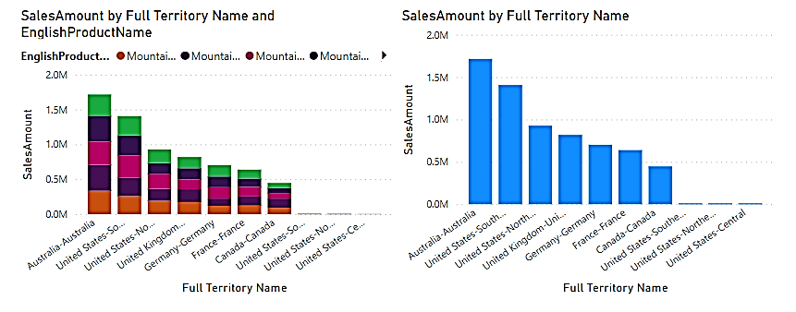

1. Let us try converting the 2nd chart to tree map. PowerBI also supports cross-filtering, try clicking on Australia in the tree map and see that the filter also applies to the 1st chart.

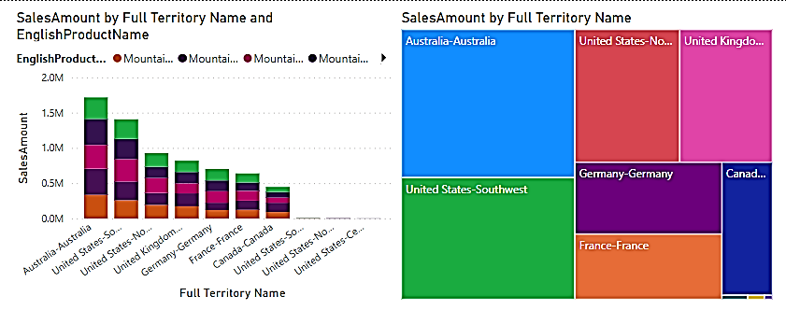

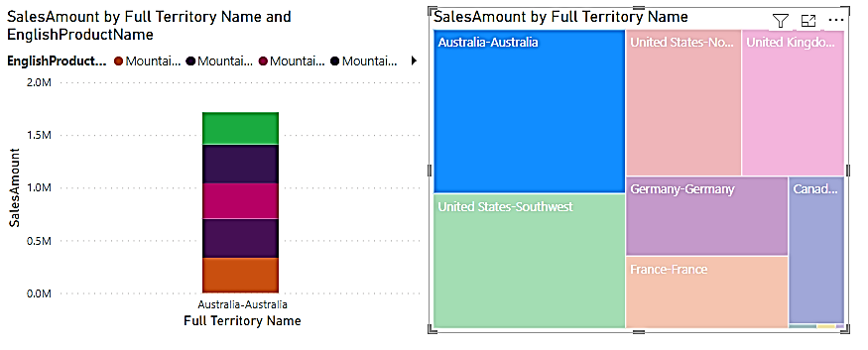

1. Copy the 2nd chart to make a 3rd chart. Convert it back to stacked column chart and resize the 3 charts so they fit nicely together on the screen.

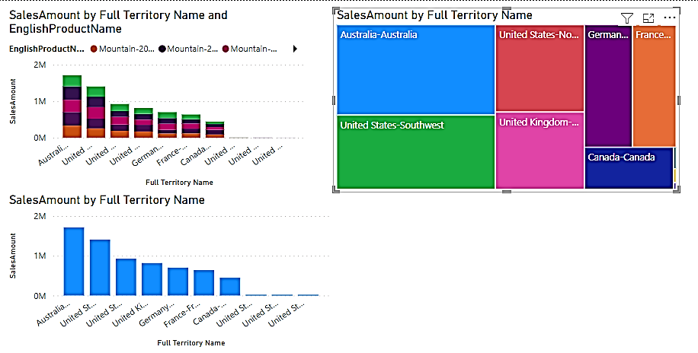

What we want to do here is to be able to navigate into the salesterritory hierarchy. SalesTerritory has group,country and region.

To create a hierarchy, click back to data view and visit the SalesTerritory table.

In the fields pane, expand SalesTerritory table🡪rclick on our top hierarchy (SalesTerritoryGroup)🡪create hierarchy. Once created, you may rename it to SalesTerritoryHierarchy, and see that the SalesTerritory Group is already part of it. Rclick the other fields and add them to the hierarchy so the hierarchy will be in this order: Group🡪Country🡪Region

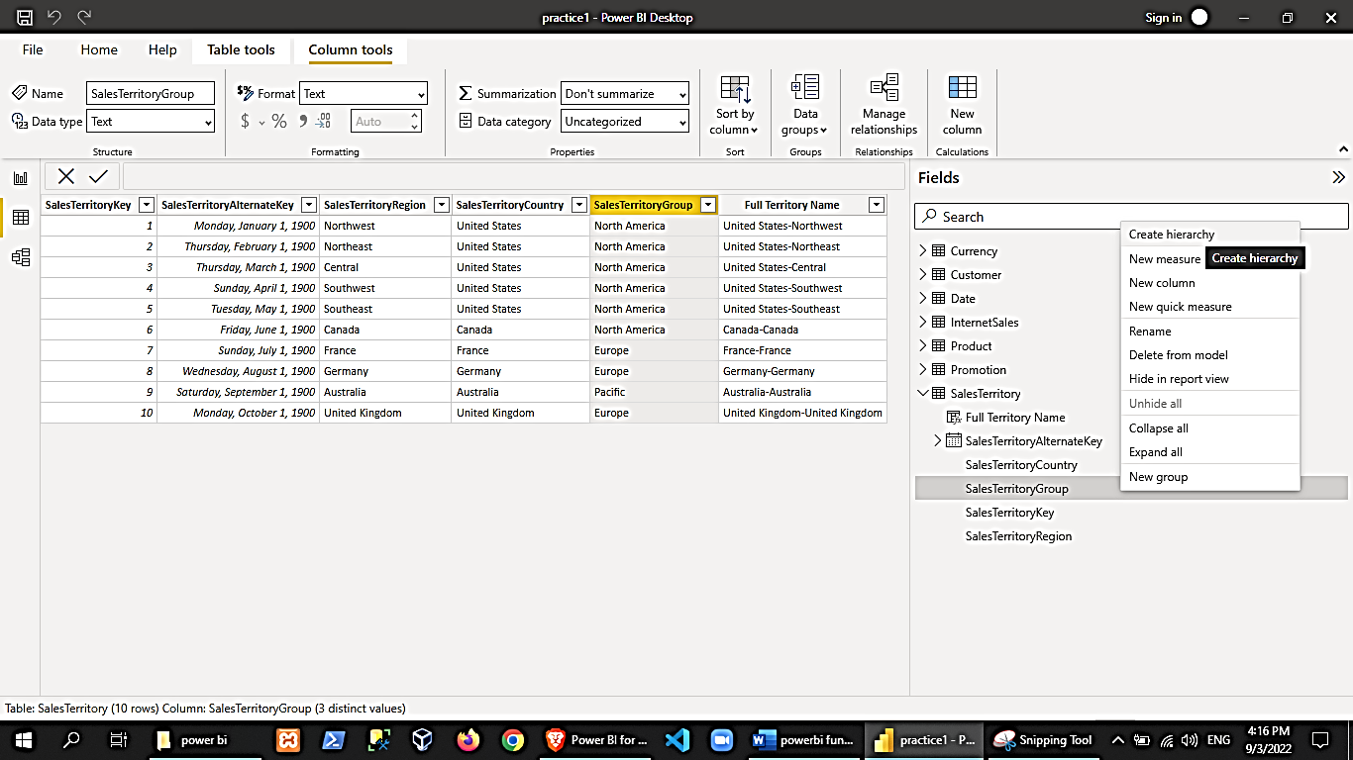 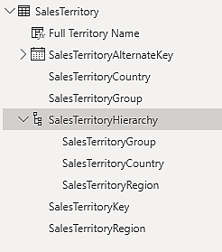

Going back to our visualization, in our 3rd chart, we can replace the “Full Territroy Name” field to our new “SalesTerritoryHierarchy”.

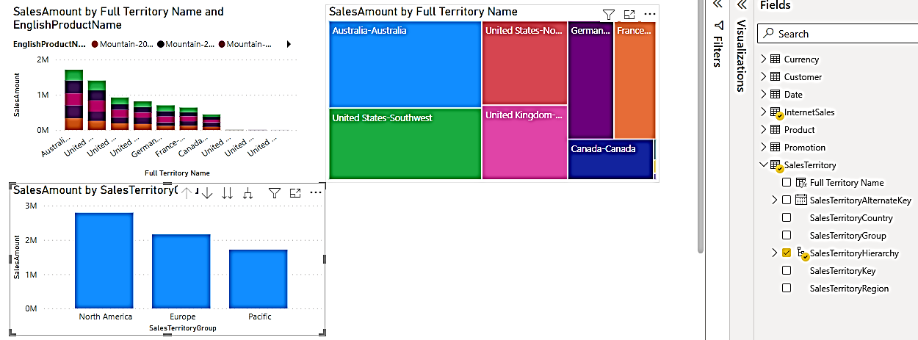

Try using the chart options to move up or down the hierarchy

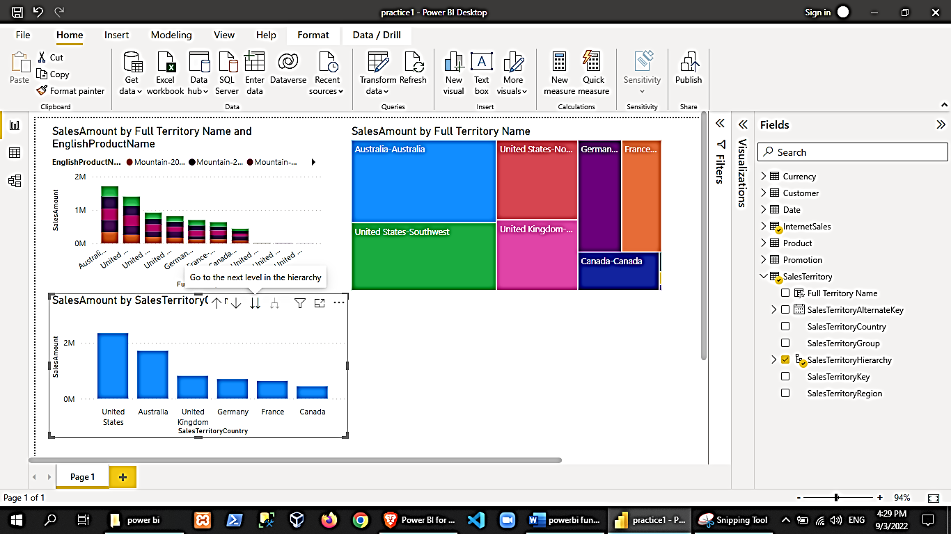

1. Let us create a new sheet by duplicating our page. Rclick on our page on the bottom section🡪duplicate page
2. For this activity, we will use our date table. Check if it is loaded and doesn’t have errors.
3. Rclick in our date table🡪”mark as date table”🡪select the column to be used (FullDateAlternateKey)

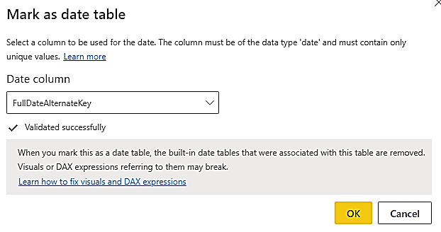

1. Go to model view and create a relationship between [Date]DateKey and [InternetSales]OrderDateKey then save and go to data view.

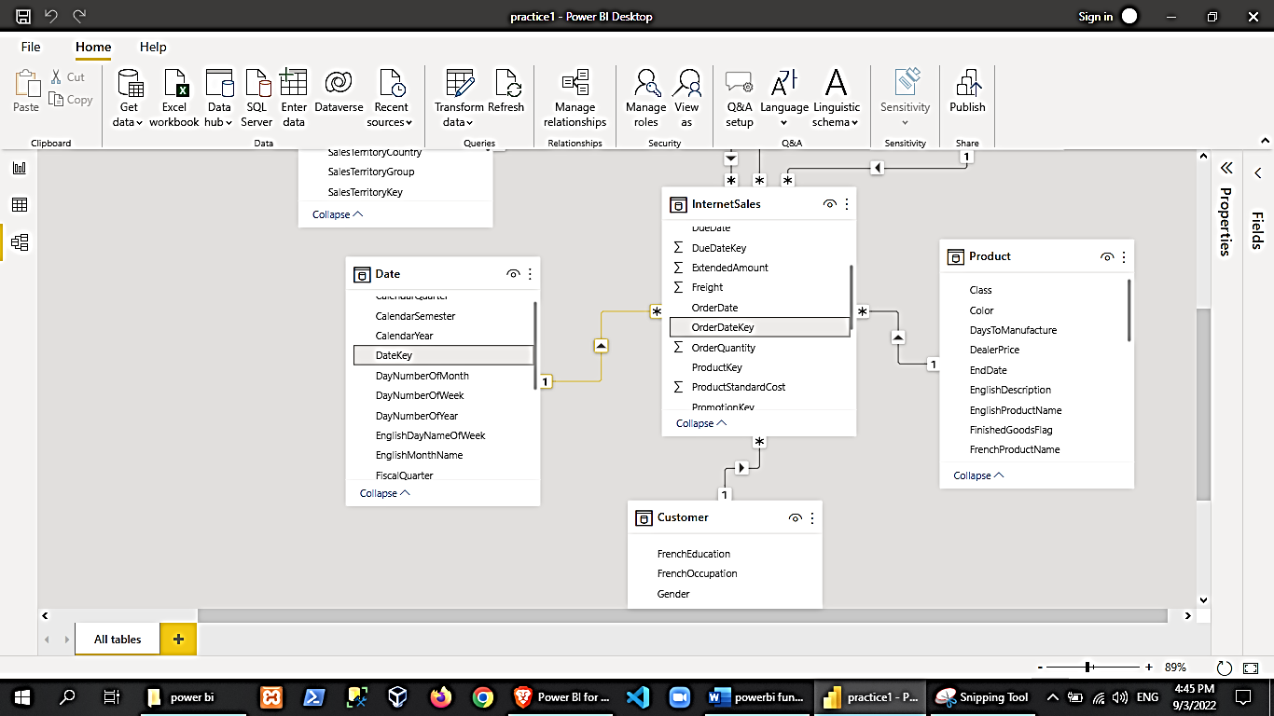

1. In the data view, let us create a new hierarchy for our date table. (fiscalyear🡪fiscalquarter🡪englishmonthname). Rename it to “DateHierarchy”.

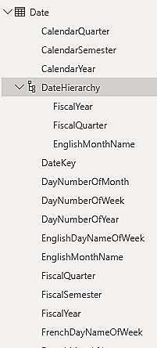

1. Create a copy of the 3rd chart to make a 4th chart. In the 4th chart, uncheck the SalesTerritoryHierarchy, check the DateHierarchy. Try navigating the DateHierarchy to view results.

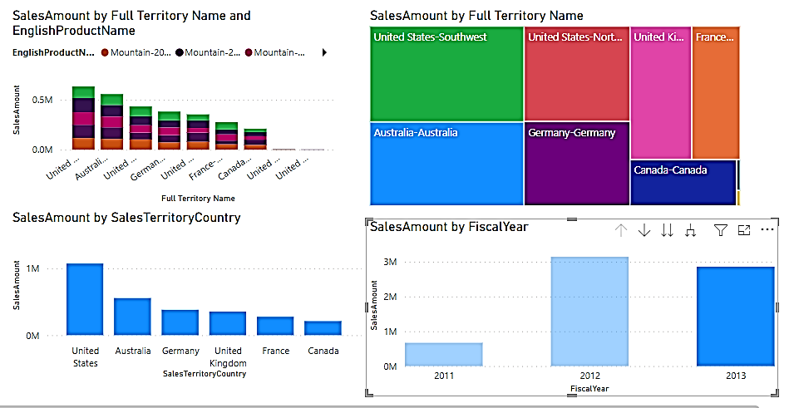

1. Add another duplicate page for more demo.
2. Delete all charts except the 4th chart, then move it to the upper left corner, then duplicate it to create our 5th chart. Convert the 5th chart to a table by clicking the “table” button in the Visualization pane.

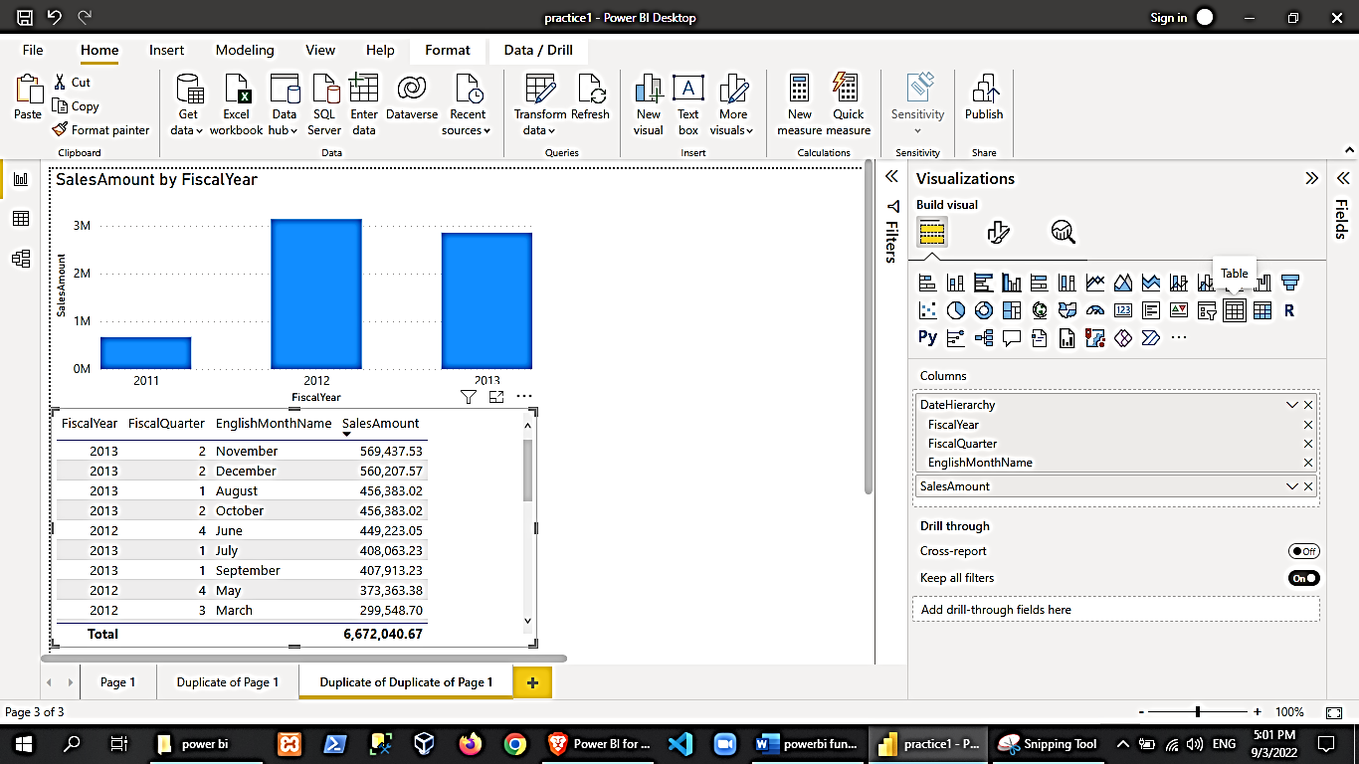

1. You can format your table (or charts) here: (try exploring formatting options)

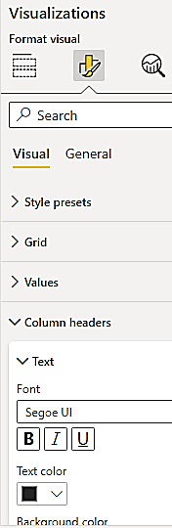

1. Add another field (SalesAmount) to your 5th chart (converted to table). You now have 2 SalesAmount fields. Under the visualization pane, you have a table data setting where you can see your columns. Rclick the duplicate SalesAmount field🡪show value as🡪percent of grand total

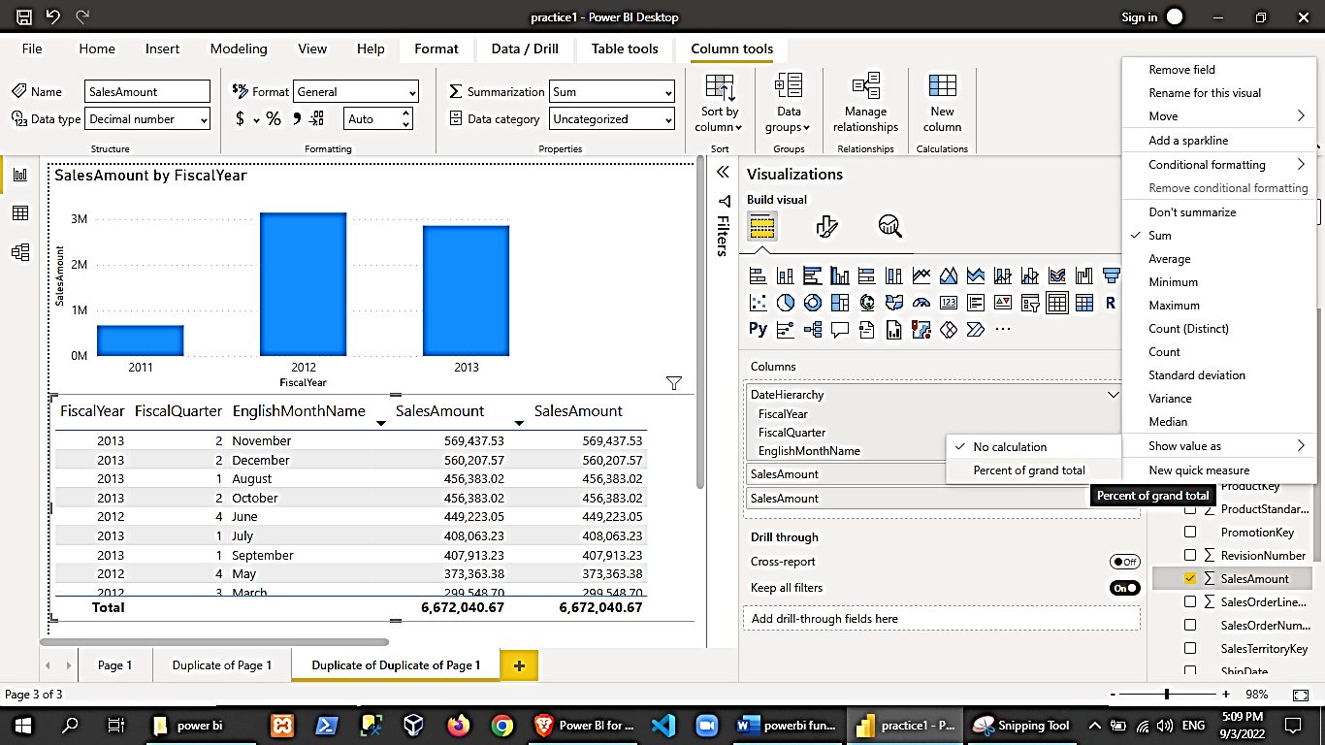

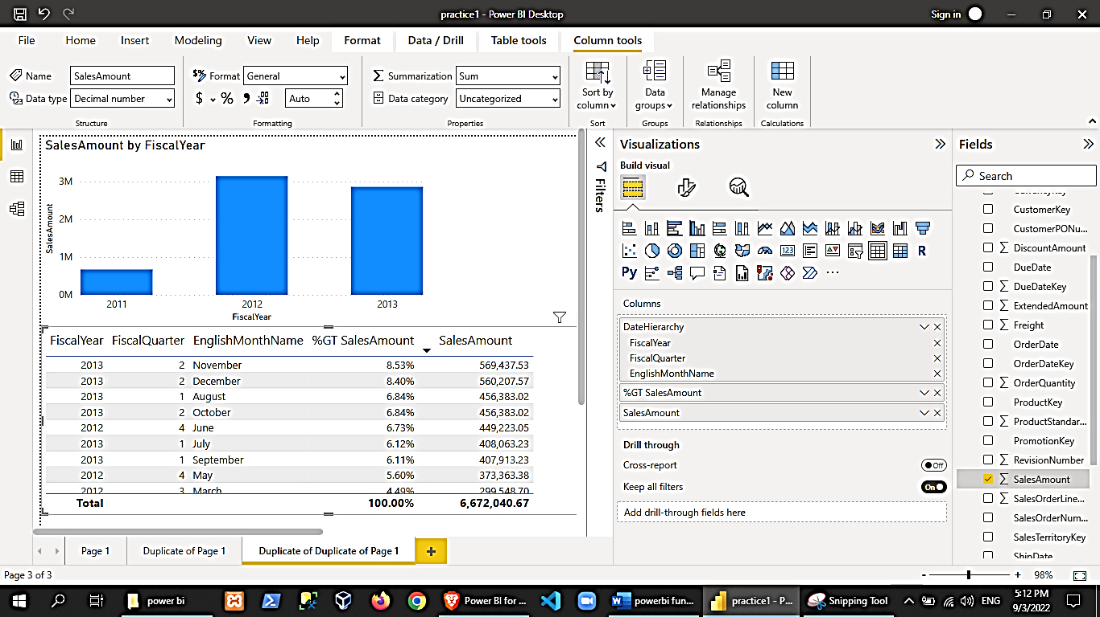

1. Let us add a new measure. In the fields pane, rclick InternetSales table 🡪 new measure. It will again open up the formula bar so type in the calculation. Then add the new column to our 5th visualization

True Cost = sum(InternetSales[SalesAmount]) - SUM(InternetSales[DiscountAmount])

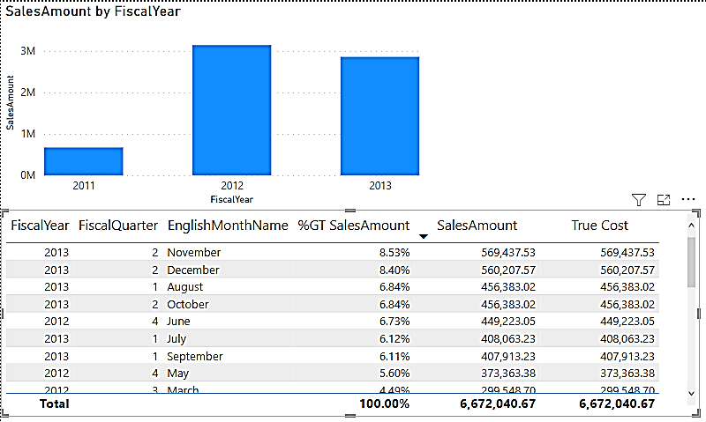

Although we have added a percentage column, we can easily do other computations like getting the Max or Min, Average, etc by clicking the drop down arrow of that column in the Visualizations pane.

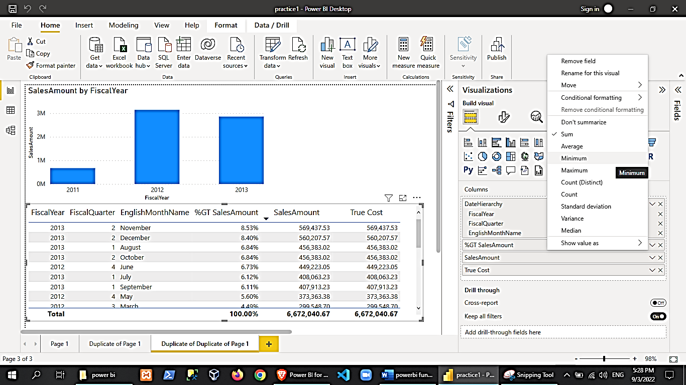

Try implementing filters as well

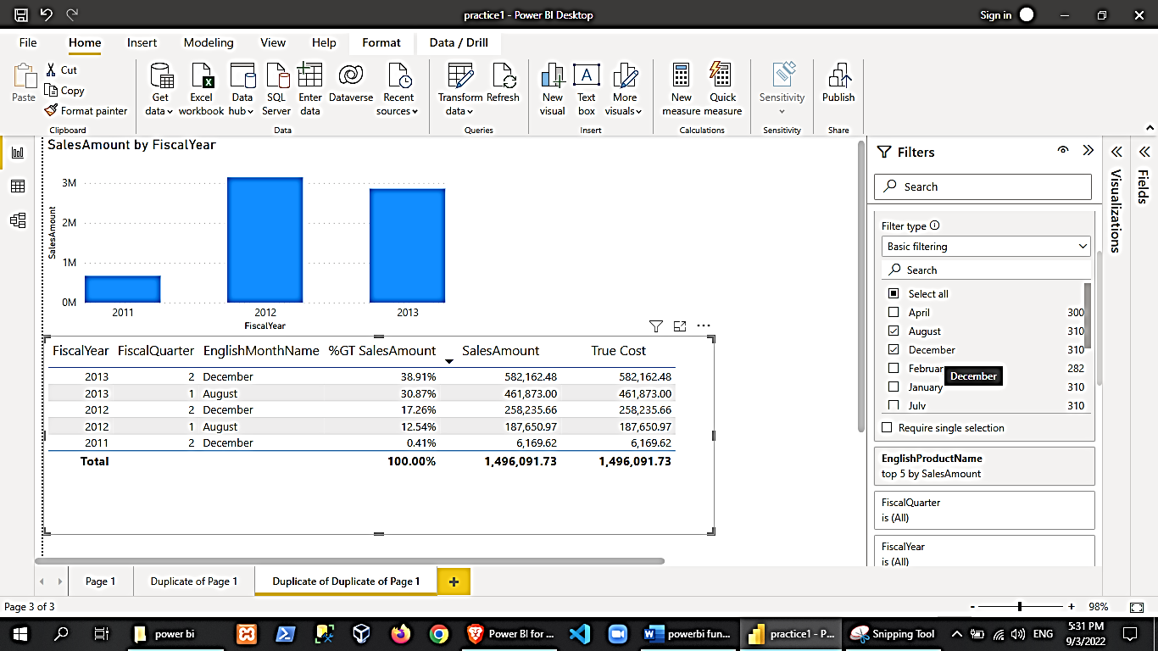

Let us try performing conditional formatting. In the visualization pane, rclick the Percentage Column we created earlier (%GT SalesAmount) 🡪 conditional formatting 🡪 background color

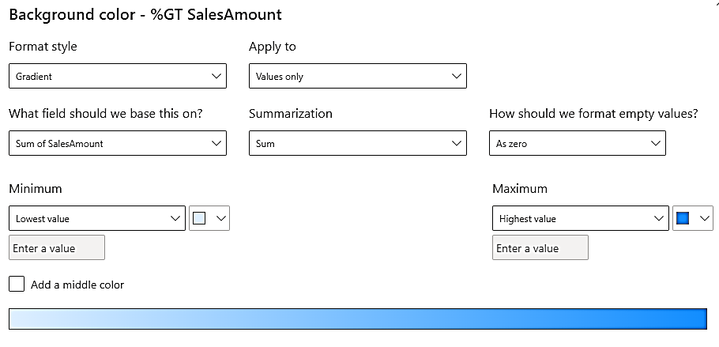

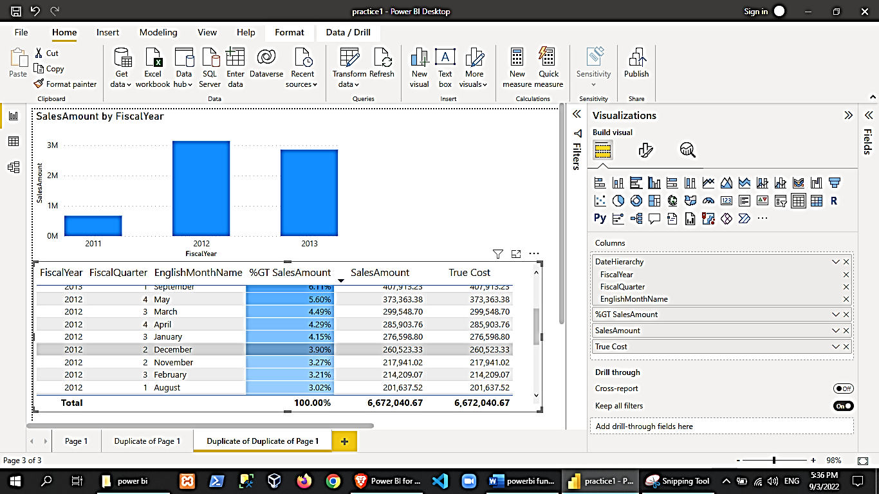

1. More on data visualization.
   1. Create a new page, rename it to “Main Report”
   2. From the visualization pane, click on “matrix”
   3. From the fields pane, select the following:

* InternetSales table🡪SalesAmount field
* Product 🡪 color
* Product 🡪 modelname

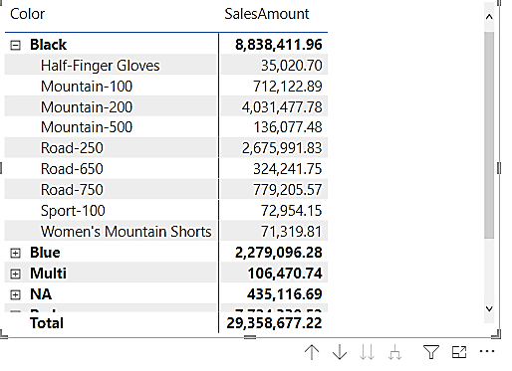

Let us change the SalesAmount view to Percentage of Column Total

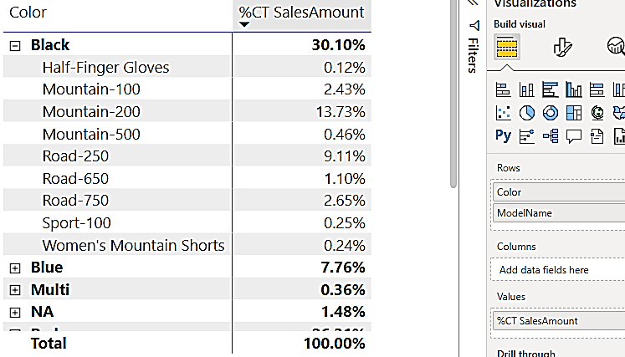

Add conditional formatting to the SalesAmount field to easily see the high and low values.

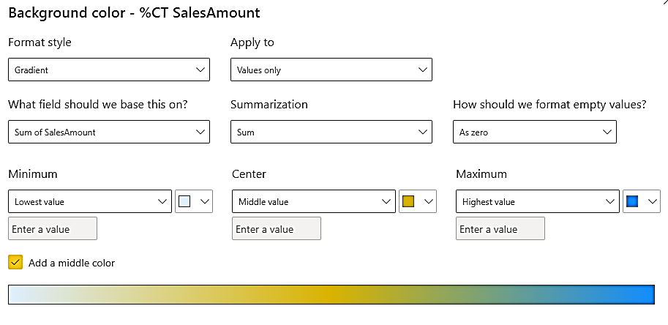 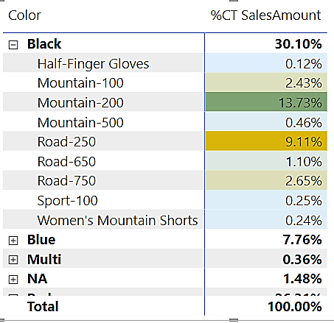

Add a stacked column chart, add fields:

* Date table 🡪 DateHierarchy
* InternetSales 🡪 SalesAmount

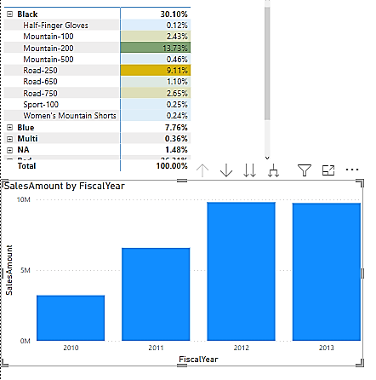

Let us impose another metric in our stacked column chart. Change the chart type to Line and Stacked Column Chart then define a metric for the line (InternetSales🡪OrderQuantity).

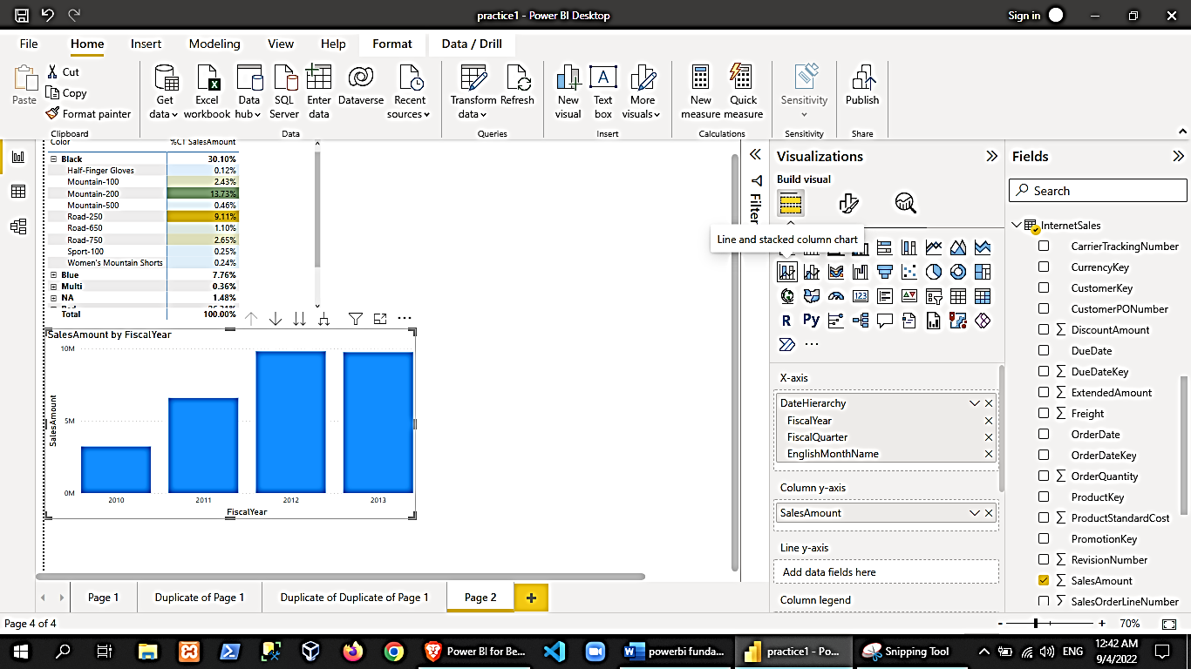 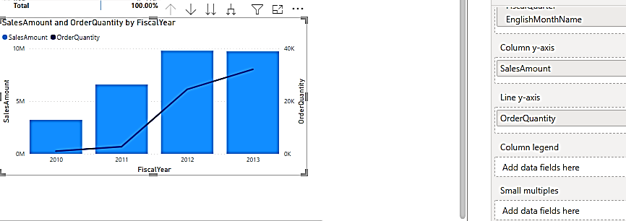

We can add a slicer filter

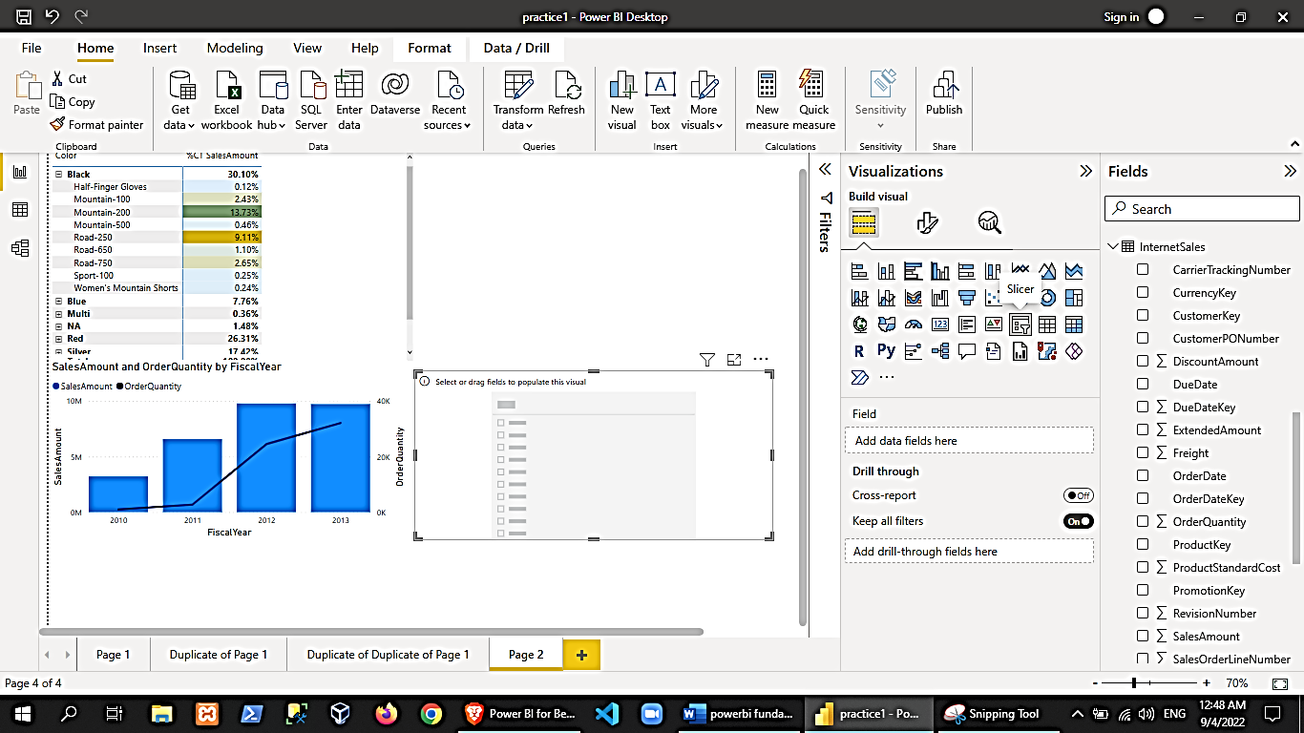

For the slicer, select the date table🡪fiscalYear. The slicer will automatically change its appearance depending on the value of the field we selected. Try using the slicer component and see the other charts are being filtered as well.

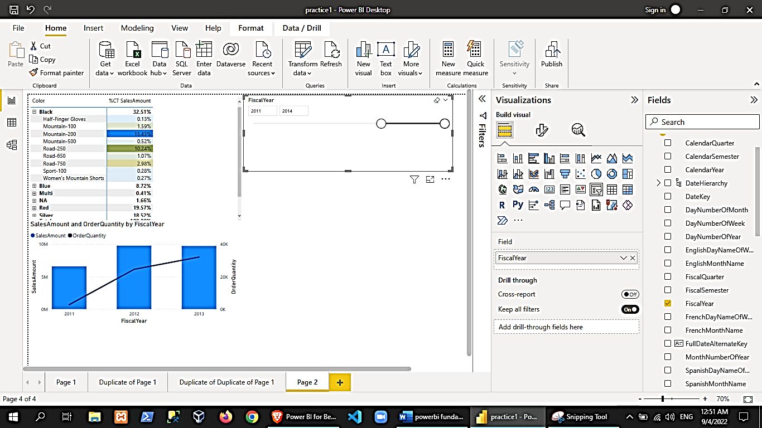

Add another slicer for the Product🡪color. You can do some formatting like change from a vertical checkbox color filter to color buttons by changing the orientation to horizontal.

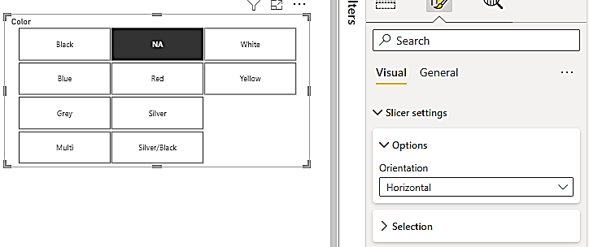

Let us add a gauge. Gauge are used to show how your sales are doing versus target and metrics.

* InternetSales🡪SalesAmount

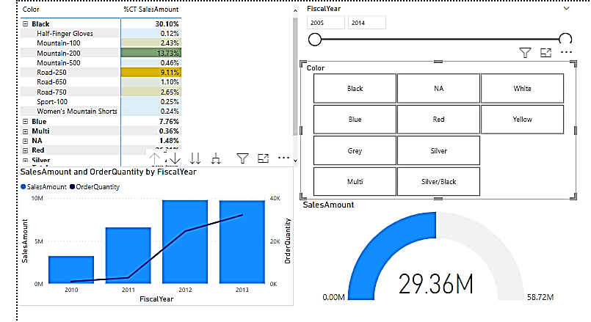

You may add textbox from the ribbon tabs to our report (ex. “Sales Report”).

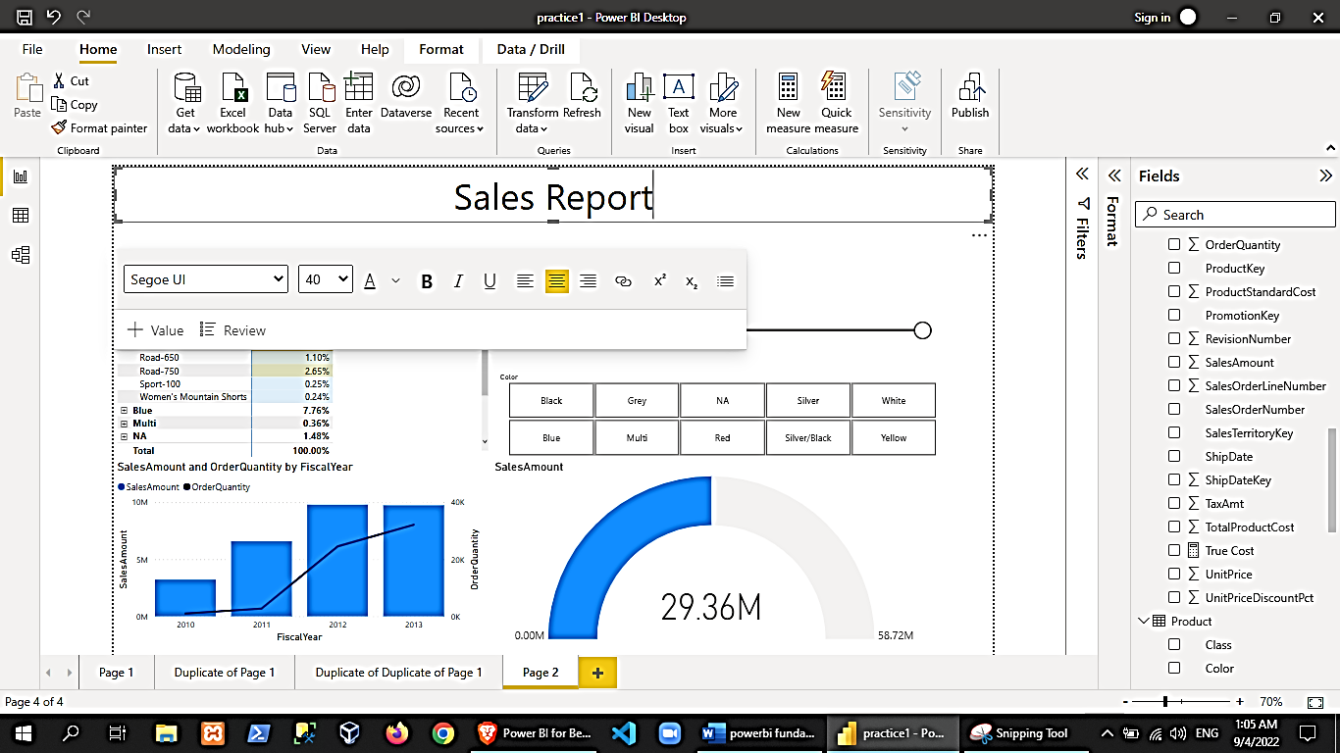

To share the report, you may:

* Save as powerbi document (.pbix)
* Export as powerbi template
* Export as pdf
* Publish the report in the powerbi service (if you have powerbi cloud)

The example below exports it as a pdf (the controls are non-interactive)

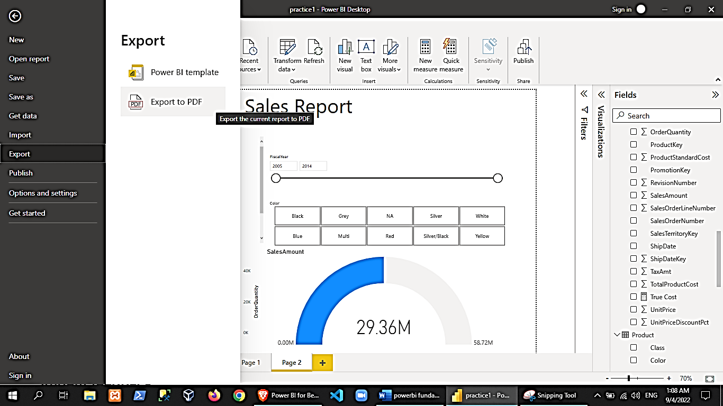 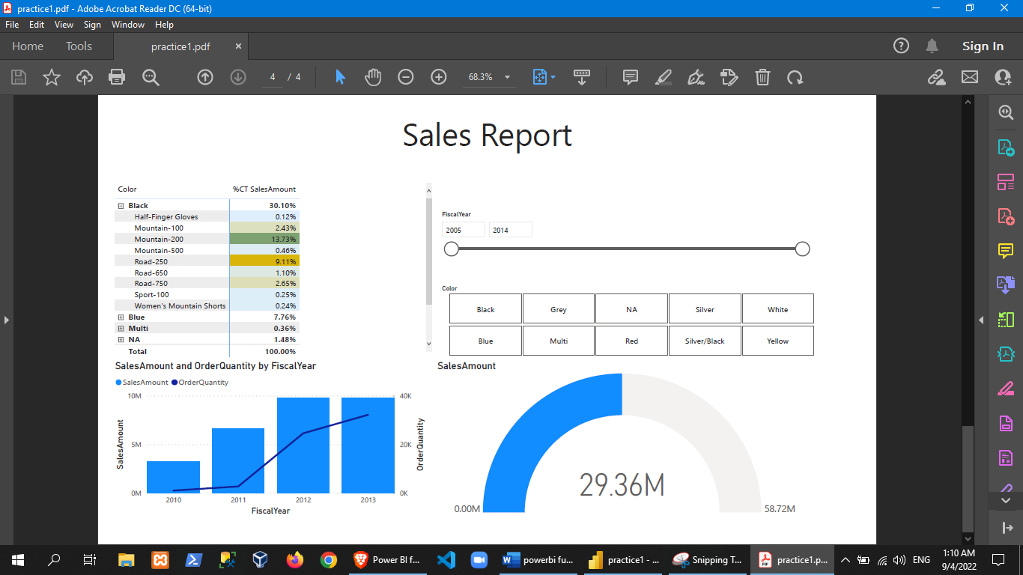

**Class Activity**

Follow Trainer’s Instruction for a sample project to demonstrate the following:

* Dax in Power BI
* Designing Power BI Report
* Tell Story with Power BI by Designing
* Publish the Report